**Deerwalk Institute Of Technology**

**Sifal, Kathmandu**

**Internet Technology**

Lab 6 FTP

**Submitted By: Submitted To:**

Name: Suryaraj Timsina Sudhir K. Maharjan

Roll No: 0235

Section: A

**FTP**

**File transfer protocol server** is used to transfer files between server and clients. All major operating system supports ftp. ftp is the most used protocol over internet to transfer files. Like most Internet operations, FTP works on a client/ server model. FTP client programs can enable users to transfer files to and from a remote system running an FTP server program.

FTP (File Transfer Protocol) is probably the most popular method of uploading files to a server; a wide array of FTP servers, such as vsftpd, and clients exist for every platform. It listens to port 20 and port 21. Port no 20 is for Data Connection or control word and port no 21 is for Data Transfer.

**Different commonly used FTP applications are:**

* Pure ftp server
* ProFtp server
* tftpd pxe boot
* Cisco ios trasfer etc
* Vsftpd (Very Secure FTP server)

**Required Package in linux system are:**

* Vsftpd for server (need to install)
* ftp for client

**Configuration:**

We can check if the port is available or not using command:

$ netstat -ntlup | grep 21

The configuration file is located at **/etc/vsftpd.conf** and modifying this configuration file, we can setup for the server configuration. Different steps to be followed can be checked from the manual or documentation for server configuration.

Different configuration parameters to be changed during server installation are:

**anonymous_enable=NO**

i.e username default during installation.

If we want to enable anonymous user to upload files in ftp server we need to enable

**anon_upload_enable=YES**

**local_enable=YES**

This will allow Linux user to use ftp service.

**allow_writeable_chroot=YES**

This is tell the Linux user to use FTP service in chrooted directory.

**ftpd_banner=Welcome to My FTP service.**

Use custom FTP banner.

To deny any user to FTP server put user-name in /etc/ftpusers

We can start client using $ ftp command:

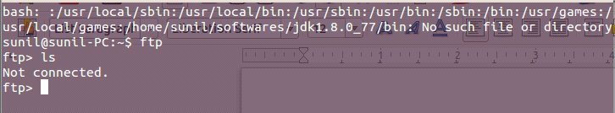

We can execute Linux command in FTP client by putting **!** at the beginning of the command.

eg

ftp>!clear

ftp>!ls

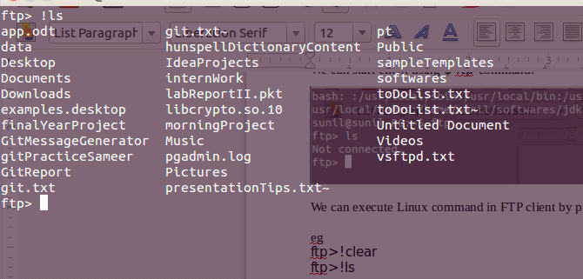

To explicitly allow user put following parameter configure in /etc/vsftpd.conf file.

**userlist_enable=YES**

**userlist_file=/etc/vsftpd.userlist**

**userlist_deny=NO**

**Different FTP Commands that can be used are as below:**

* put → put single file or upload single file to FTP server
* get → download single file from FTP server to current Linux location
* mput → uploads multiple file to FTP server
* mget → download multiple file from FTP server
* ls → list files and directory in FTP server
* dir → same as ls
* cd → change directory in ftp server